Installation instructions for the CodeProject “Merging SAP PS with MS Project”.

**MS Project Professional 2007 Client and MS Visual Studio 2008 are required.

1. Unzip the “Merging SAP PS with MS Project.zip” file to a working directory. This creates the “Projects” directory and sub folders listed below.
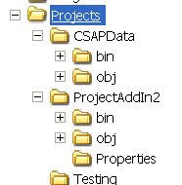

2. Run MS Visual Studio 2008 and open the:
D:\Projects\ProjectAddIn2\ProjectAddIn2.sln

3. In the ProjectAddIn2 -> Properties -> Settings page modify the settings to match your configuration:
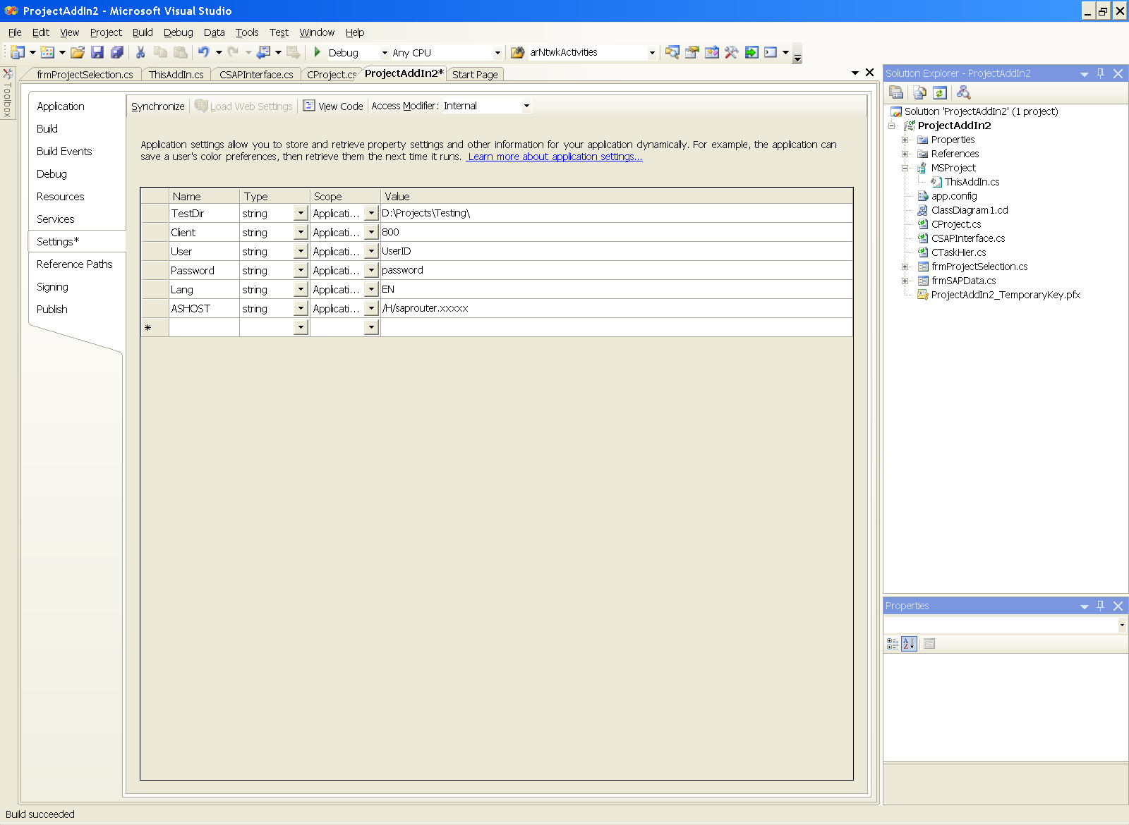

4. Make sure that the solution reference to CSAPData points to:
D:\Projects\CSAPData\bin\Debug\CSAPData.dll
5. Compile the project and run it.
6. A merged working copy of the selected SAP Project is saved to the “TestDir” listed above as a MS Project .mpp file.
7. The SAPProject.mpt template file in the TestDir folder has our global constructs.
8. To recompile the CSAPData.dll you must open the project in MS Visual Studio .Net 2003. There is a reference article listed in the “CodeProject Merging SAP PS with MS Project” document detailing how to do this.

Please feel free to send any questions or pointers to PBremner@bak.rr.com or go to www.VisualSAP.net and use the contact option (top center).

Sample project (which you don’t have in your SAP system).

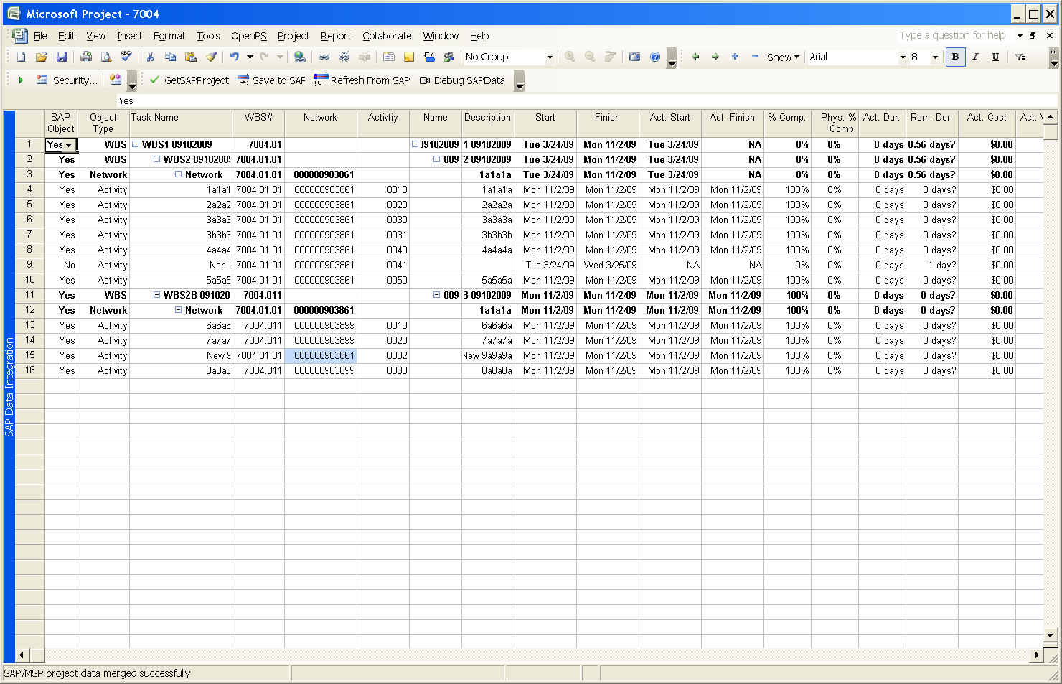

Alternative SAP Connection string:
String sConn = "CLIENT=" + Properties.Settings.Default.Client +
" USER=" + Properties.Settings.Default.User +
" PASSWD=" + Properties.Settings.Default.Password +
" LANG=" + Properties.Settings.Default.Lang +
" ASHOST=" + Properties.Settings.Default.ASHOST +
" SYSNR=" + Properties.Settings.Default.SYSNR;

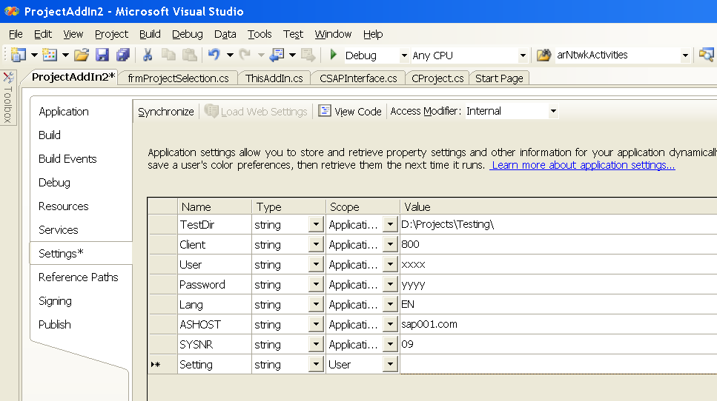

Running the Applet
This project updates or inserts a new Network-Activity (MSP Task) to/from SAP<–> MS Project.

- From MS Visual Studio, run the project. You should get the following MS Project screen. The status bar tells us the “SAP Addin loaded successfully”.
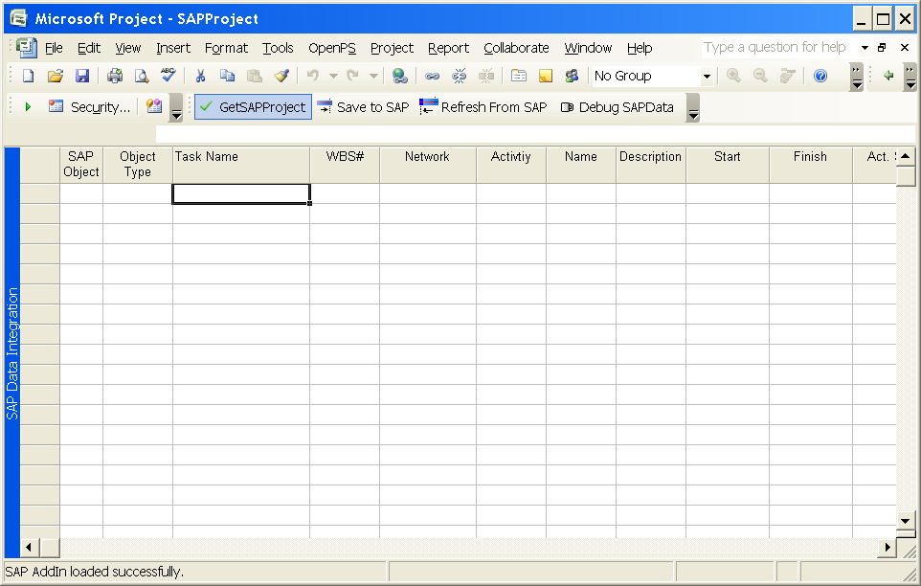

- Click on the “GetSAPProject” button. This will log in to your SAP system and retrieve a list of available SAP projects. Select a project.
- If the selected project (ex 7004) exists as an MSP .mpp file in the TestDir the SAP Project and the MSP .mpp file are merged together.
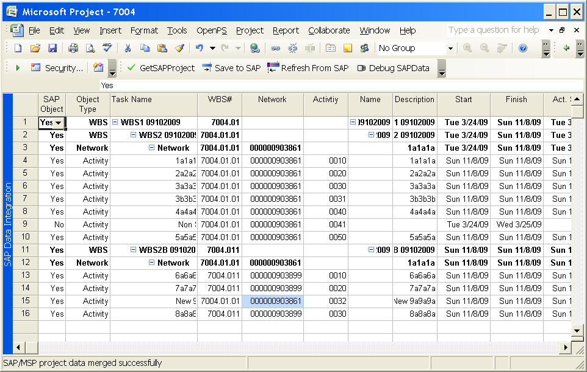
- Lets insert a new Activity task and set the system to just move our new activity/task from MSP to SAP. We set the “SAP Object” field to “No” for all tasks except our new task. On task 17, we populate the:
SAP Object = “Yes” , our control field
Object Type = “Activitiy” , our control field
WBS# = “7004.001” , SAP field
Network = “000000903899” , SAP field
Activity = “0031” , we create, must be unique in SAP

- Click on the “Save to SAP” button. Status bar says “Project saved to SAP successfully.
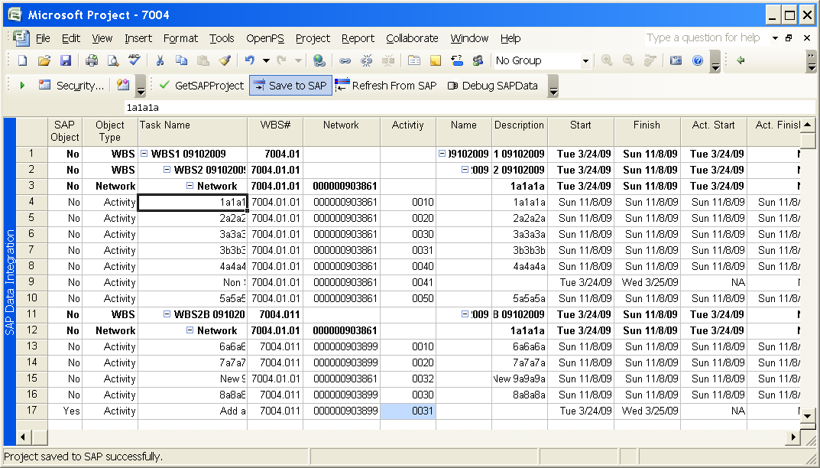

If you have any question email me at PBremner@bak.rr.com

Thanks,
Phil

